

**Laiba Nasir**

Roll no : 204

Bs (Computer Science)

Section : A

2ND Semester

FINAL PROJECT OF

DATABASE

Good Morning , everyone. Today, I will be presenting my Library Management System project, which is built with a strong focus on database design and management. The system uses a structured database to store and organize information about books, members, and transactions. By integrating SQL queries and relational database concepts, the project ensures accurate record-keeping, quick data retrieval, and efficient management of library operations.”

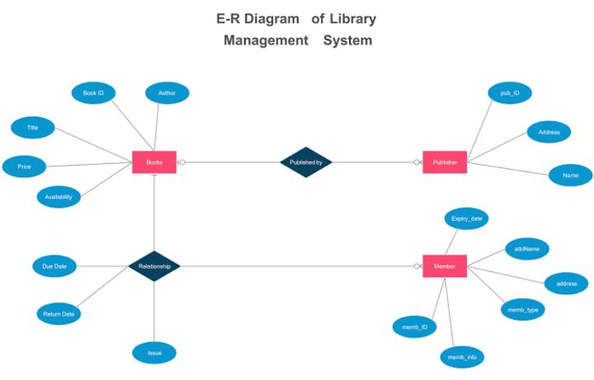

ER Diagram of library management system.

SO, Here is the query of library management system in database.

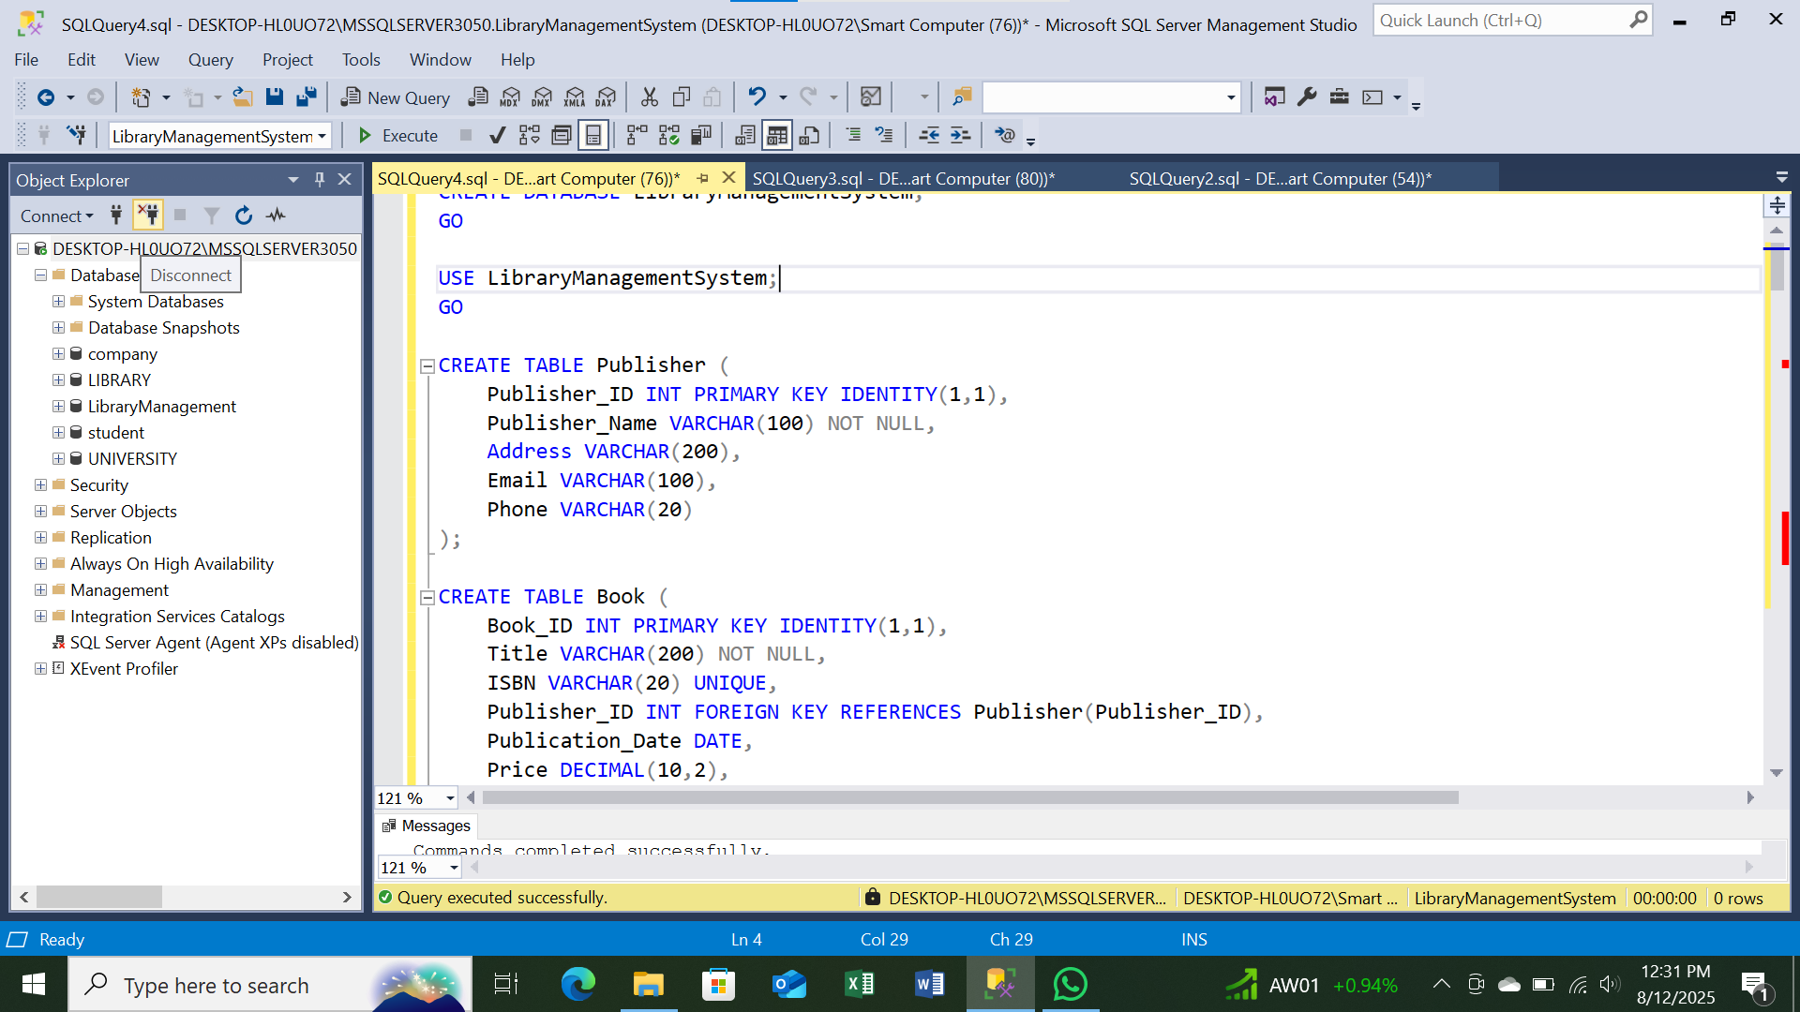

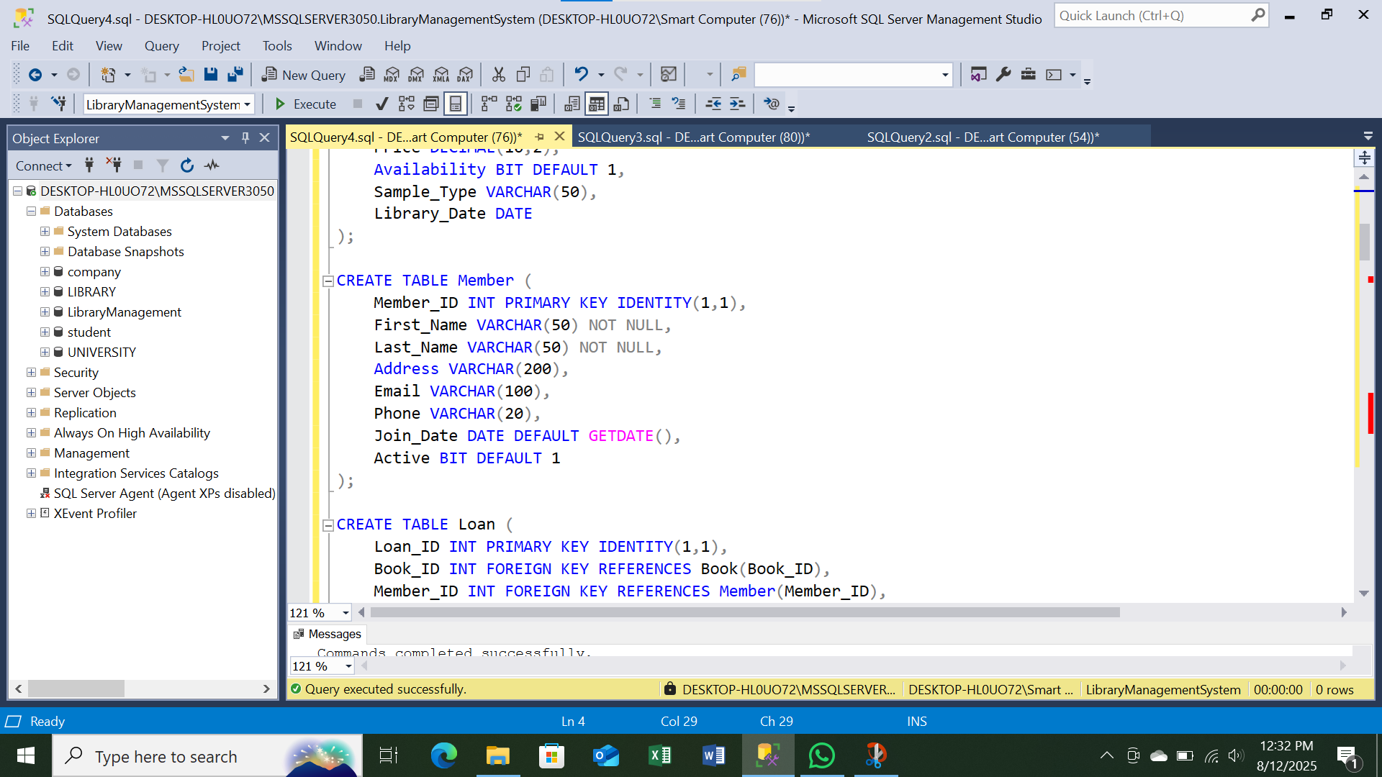

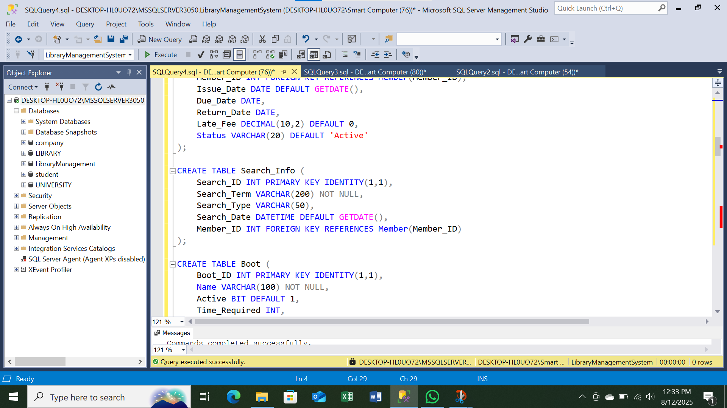

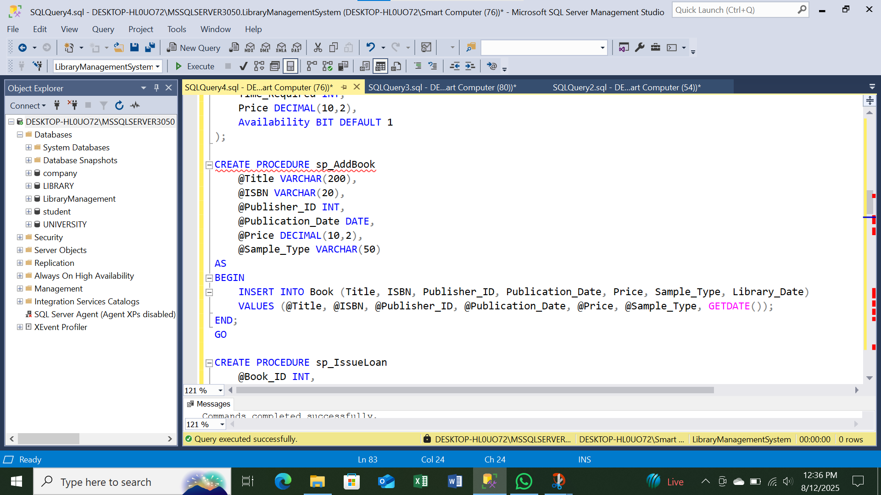

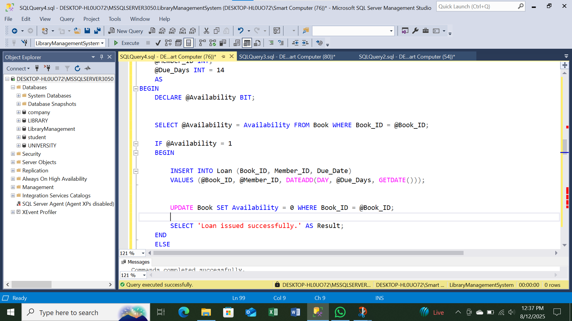

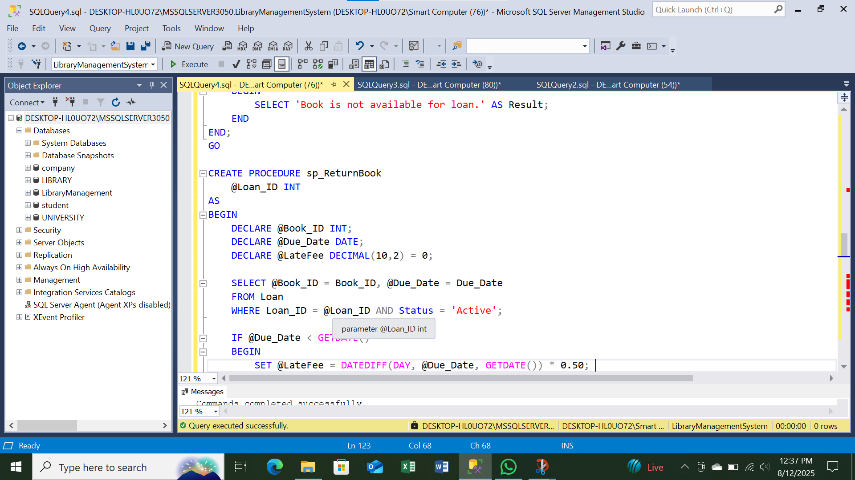

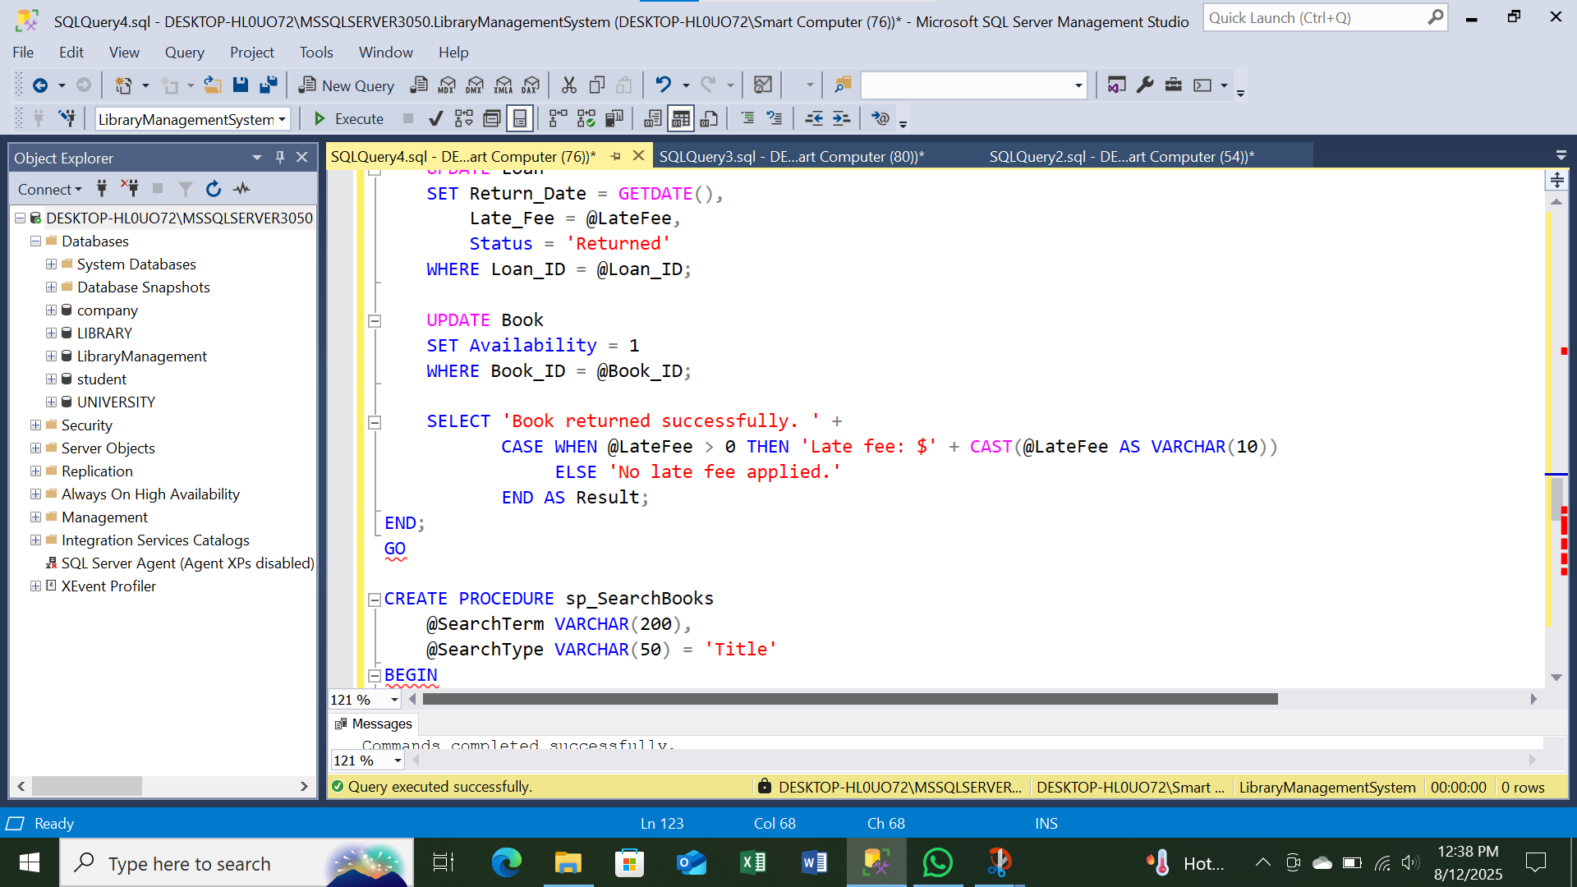

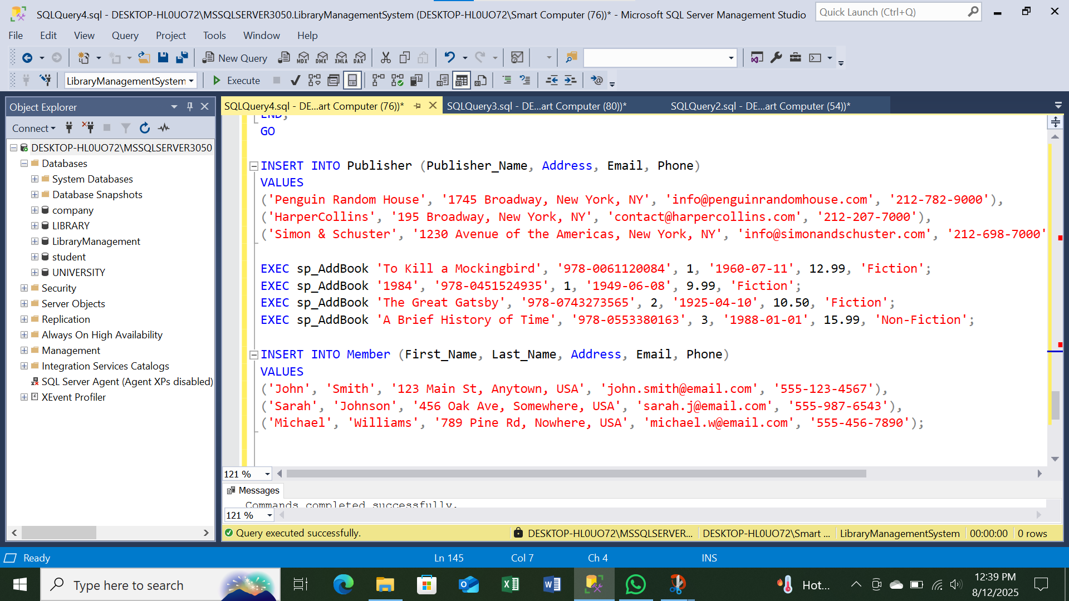

THANK YOU